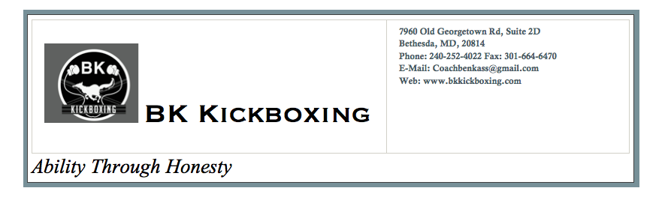

Name:
Date:
Mobile:
Birthdate:
Address:
Email:
Emergency Contact:
(Name, Phone, and Relation)

I ________ENTER NAME HERE, understand that there is a risk of personal injury in the course of instruction, and with this knowledge, agrees to assume risk of any injury and damages to the participant during the seminar. Specifically, the participant accepts the risks and agrees to hold harmless, BK Kickboxing and all other individuals, instructors, independent contractors, or personal trainers, fellow students, from all losses, damages, or injuries.
I ________ENTER NAME HERE, further agree to follow instructor rules and observe safety rules.
Because of the physical demands of martial arts and/or personal defense instruction, participant understands that he/she must be in good physical condition to participate. Students understand that in the case of injury, the only medical treatment BK kickboxing will provide is first aid.
Participant agrees that any pictures, audio, or visual recordings taken of him/her in connection with BK Kickboxing can be used for publication and promotion without further consent or compensation. In addition, participant allows BK Kickboxing to communicate via email and send promotional material.

Physical Questionnaire
 |  | Yes | No
1 | Have you been in contact with anyone who tested positive with COVID 19?
2 | Have you been experiencing a dry cough or fever?
3 | Have you been to a gathering of more than 8 people in the last 2 weeks?
4 | Have you been experiencing unexpected difficulties breathing or wheezing?
5 | Have you been diagnosed with and/or receive treatment for a respiratory or heart condition?
6 | Do you feel pain in your chest when you do physical activity?
7 | Do you have chronic dizziness during physical activity?
8 | Do you have a bone or joint problem that could be made worse by a change in your physical activity?
9 | Is your doctor currently prescribing you blood pressure medications?
10 | Do you suffer from visual impairment during vigorous exercise?
11 | Do you know of any other reasons why you should refrain from vigorous exercise?

By endorsing below I agree to the terms and conditions of attending an outdoor and contactless class with BK Kickboxing.
Participant Signature Date:

Parent/Guardian Signature Date:

